**STAFF OF THE FAT KING: OFFICIAL PLAYER’S MANUAL**

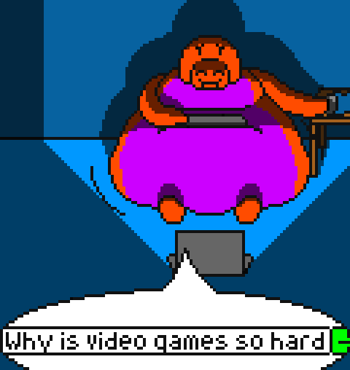

**INTRODUCTION:**

Thank you for checking out my game! I’ve been working hard on it, and I’d say that the effort is finally starting to pay off! Well, for people who know what they’re doing, it does. The game doesn’t have much in the way of tutorials or anything, so for players to know how to access what I’ve been working on, they would need to have joined from the start, scour the patch notes & Discord, or just press things until obesity happens.

Not anymore.

**THE OVERWORLD MENU:**

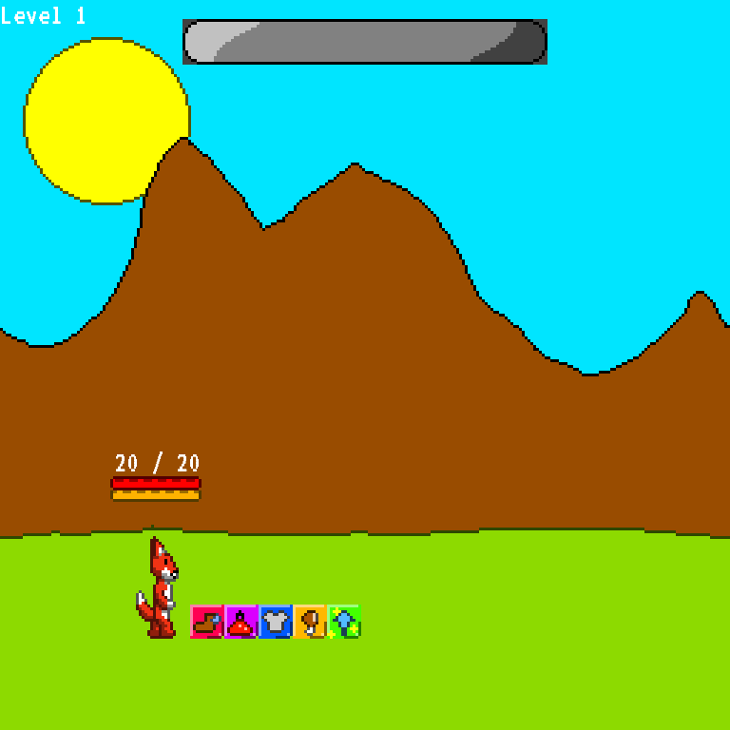

When the game first starts, you see this guy shuffling along, some buttons, and a health bar. What to do? Press the buttons, of course! The first three buttons don’t do anything, but they will get uses in later patches. The other two buttons, however, are somewhat important.

**THE FOOD MENU:**

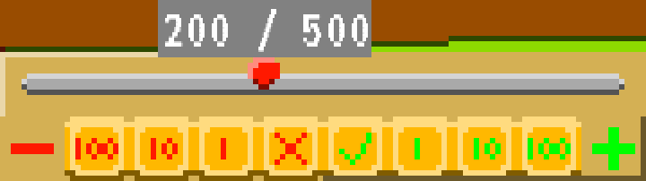

In Staff of the Fat King, enemies don’t give you experience. Rather, they drop food. Food can be used for many things, but eating it is (gasp) one of the most vital. When this menu is open, you can click the little buttons on the bottom to select however much food you want to eat. The total is displayed above the cursor on the right, while the selected amount is the number on the left. You gain one experience point per food eaten, which can help you progress to a high enough level to earn the Staff of the Fat King.

**LEVELING UP & GAINING WEIGHT:**

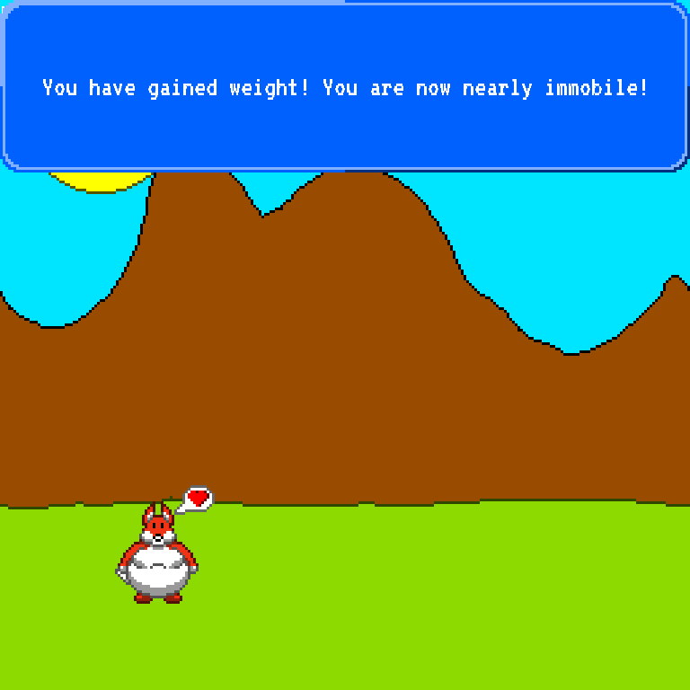

SotFK would be a bit of a disappointment if our foxy friend stayed a twig throughout the entire adventure, wouldn’t it? As mentioned before, eating food gives the player experience, which eventually leads the player to level up. After you have force-fed your avatar enough for him to grow ten levels, his belly will follow suit and expand, causing the fox to gain weight. His weight gain starts out somewhat mild, as he goes from being underweight to a standard size and mildly chubby, but his weight gain accelerates with every pound of flab added to his frame. Naturally, however, he needs a diet just as intense to keep up such an impressively lardy appearance, so the food needed to grow levels also steadily increases. Eventually, he becomes the mountain of fat he needs to be to wield the Staff! This is all fine and good, of course, but it raises the question; how does such weight gain help? Well, it helps by giving stat points. What are those for, however?

**STAT POINT MENU:**

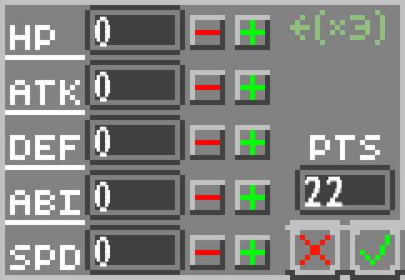

This is where the second menu option comes into play. When levelling up, the player gains absolutely no stats. A level 99 player without this menu will be just as weak as a level 1 player, nothing earned but a massive gut. However, whenever you gain stat points, you can distribute them across your stats here. Clicking the plus sign next to a stat will distribute points to it, while clicking the minus will take points away. Left clicks add & subtract points one-at-a-time, while right clicks add ten points. HP adds 3 points to your health, ATK increases damage your normal attacks do in battle, DEF reduces the damage you take, ABI increases the strength of your abilities, and SPD determines who attacks in what order in a battle. You can click the green check mark to confirm your changes or the red “X” to cancel.

**BATTLE:**

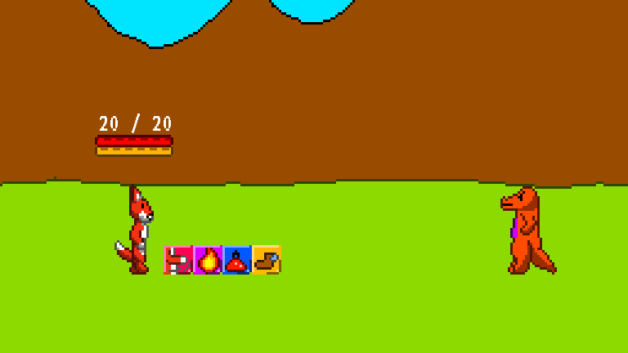

Now that you know about stats and stuff, it’s time to learn about combat. Again, several of the icons here are not complete, those being the last two. The first two, however, are fully functional. The first button is a super-simple attack. You click the button and click the enemy, and then the fox will punch his target when it gets around to his turn (Remember, while you may select an attack first-thing, you may not be the first to attack in a battle). The enemy will also try and do the same to you. However, unlike the enemy, you have an additional defense at your disposal.

**BLOCKING:**

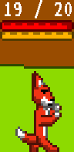Right before being hit by an enemy, you can left click to perform a block. The block animation only lasts a split second, but using it with the perfect timing will drastically reduce the damage your enemy does. Be careful to not spam-click endlessly, however, since the block has a short cooldown. To help with timing, try to learn each enemies’ tells. For example, the lizard shown above will perform a short hop before attacking.

**FOOD TOSS:**

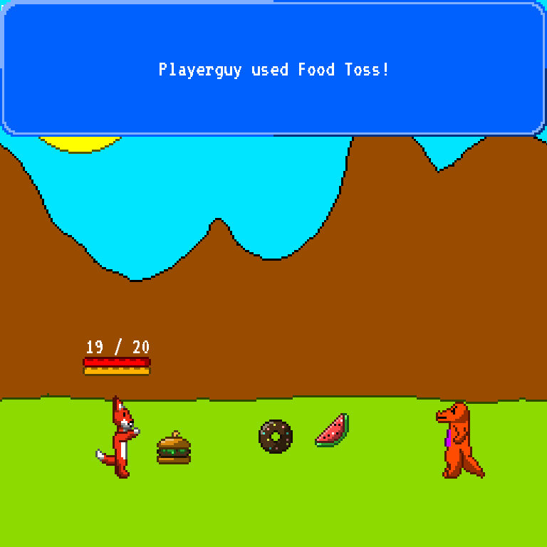

The enemies have been giving you food for free, so why not return the favor? Probably the most important tool in the player’s arsenal, Food Toss lets the player toss oversized food at enemies and fatten them to kingdom come. The player is given five seconds to try and toss as much food at the enemy as possible, although the player can only throw ten foods per turn. When the food hits the enemy – it can hit anywhere, I’m not making Dark Souls over here – the enemy will eat it. What will this force-feeding do, however?

**FATTENING ENEMIES:**

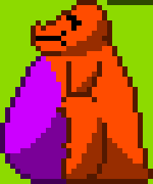

A good rule of thumb for Staff of the Fat King is that, if it moves and has a belly, it’ll get fat. Enemies are no exception. When enemies eat food, it moves up a counter shown over its head. When the counter fills up, it restarts and the enemy gains one weight level. Upon reaching the maximum weight level, the enemy will be enough of a lardbag to be entirely immobilized, stopping them from attacking. Immobilized enemies will gradually lose weight, however, stopping when they reach the next highest weight level. Feeding an enemy beyond their immobility point also has a purpose. While the enemy does not visibly gain weight, it significantly complicates its ability to work off the excess calories, stunning the enemy for another turn every time the counter ticks over again. It should also be kept in mind that enemies will not eat more food when immobilized; you can only get them to go over their maximum size by feeding them massive amounts of food before they put on the weight from their meal. Also, keep in mind that different enemies have different interactions with food. Bears, for example, need more food to gain weight, have more weight levels, and slowly lose armor as their soft belly grows larger.

**HOTKEYS:**

Now that you know how the game works, it’s time to learn how to surpass its limits. Since the game is in such early development, many tools the player would normally have are not implemented yet, so you can use the following cheats to do what you couldn’t before.

* “F” gives the player 100 more food.
* The right alt key will grow the fox one level with no food cost.
* The right shift key will grow the fox ten levels, guaranteeing a size increase (unless they hit the level cap).
* “E” spawns a bear.
* “H” restores all health to the player.